Nama : Abdi Akhsanul Afkar

NIM : 18090048

Kelas : 5C

PRAKTEK W3

1. Code

Matakuliah.php- application/controller

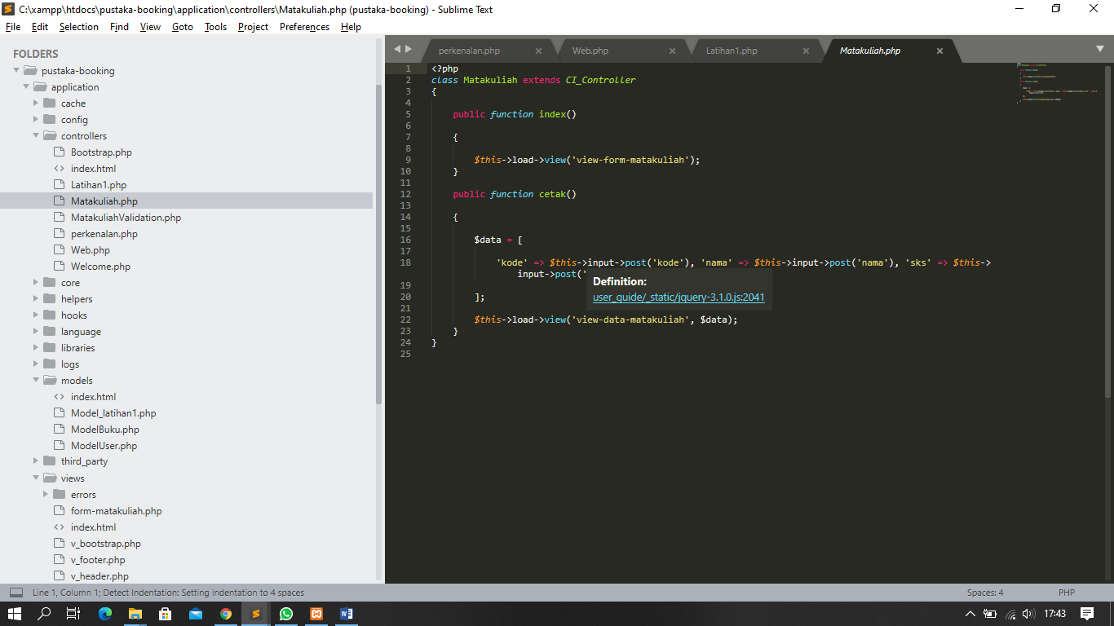

View-form-matakuliah.php-application/view

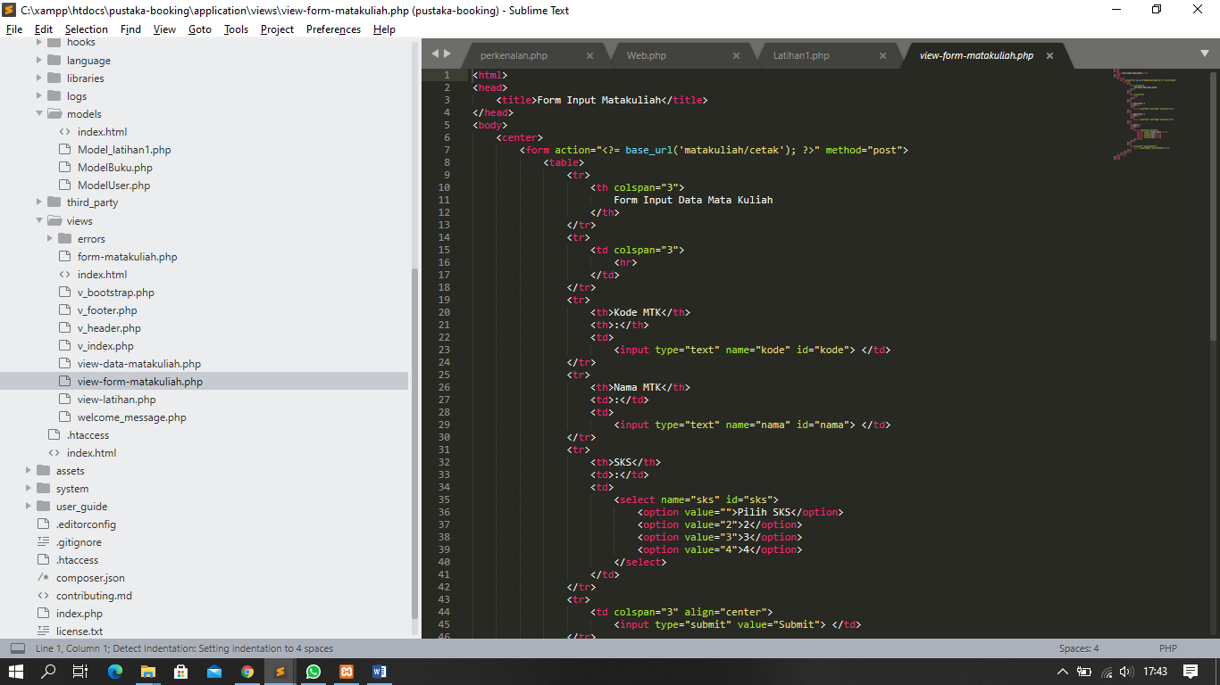

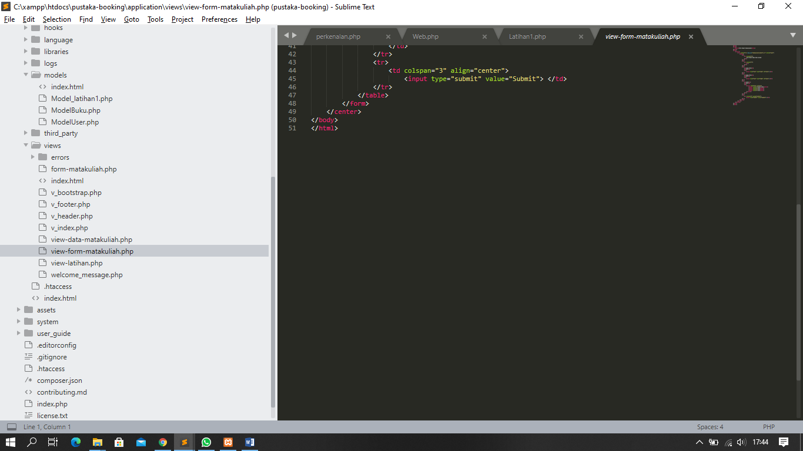

1. URL

[http://localhost/pustaka-booking/](http://localhost/pustaka-booking/Matakuliah)

1. Screenshot hasil

